WOODROW WILSON ELEMENTARY SCHOOL
BINGHAMTON - SCHOOL

School Detail :-
Our Wilson School Staff is dedicated to providing a campus that promotes and reinforces a clean, safe and orderly learning environment to allow every student the opportunity to achieve to his or her fullest potential.
Our Wilson School Staff is dedicated to providing a campus that promotes and reinforces a clean, safe and orderly learning environment to allow every student the opportunity to achieve to his or her fullest potential.
Our Wilson School Staff is dedicated to providing a campus that promotes and reinforces a clean, safe and orderly learning environment to allow every student the opportunity to achieve to his or her fullest potential. Our Wilson School Staff is dedicated to providing a campus that promotes and reinforces a clean, safe and orderly learning environment to allow every student the opportunity to achieve to his or her fullest potential. Our Wilson School Staff is dedicated to providing a campus that promotes and reinforces a clean, safe and orderly learning environment to allow every student the opportunity to achieve to his or her fullest potential.
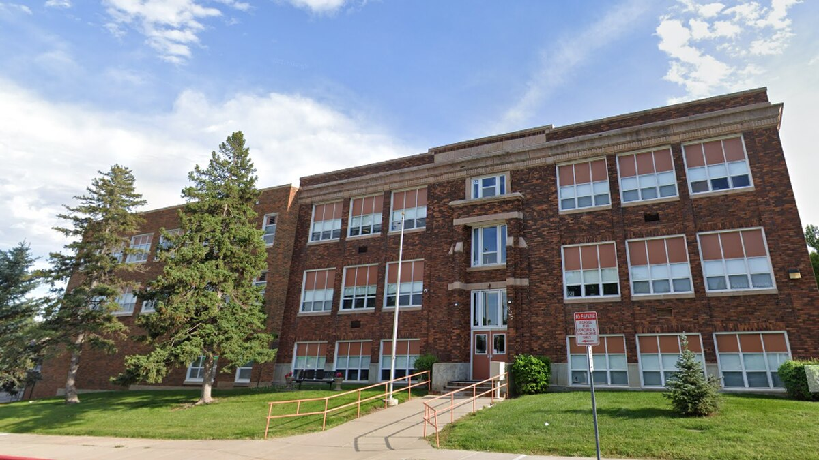

MINIMUM CAPACITY :-
The Minumum intake capacity
of students is between 3000-3500
children

LIBRARY :-
The Libarary is Available.

CANTEEN:-
The Canteen Facility is Available.

BOARDING :-
No availablility of boarding.

SPORTS :-
There are different categories
sports available.
Girls Volleyball
Boys Volleyball
Football

